AIM:
Interface two switches and LED’s to Arduino UNO using C++ in ThinkerCad.

SOFTWARE:
ThikerCad

THEORY:
This project is about working with two LEDs with two PUSH BUTTONs.
For one set of LED and the Push button , when button is pressed LED is set ON and when the button is released, LED will be set OFF. For the other set, it’s the opposite effect.

s1 | s2 | LED1 | LED2
ON | ON | OFF | OFF
ON | OFF | OFF | ON
OFF | ON | ON | OFF
OFF | OFF | ON | ON

Here we represented the working of pushbuttons and switches as,
ON with ‘1’ , OFF with ‘0’

s1 | s2 | LED1 | LED2
1 | 1 | 0 | 0
1 | 0 | 0 | 1
0 | 1 | 1 | 0
0 | 0 | 1 | 1

For LED1

LED1 = S’₁S₂ + S’₁S’₂
= S’₁(S₂+S’₂)
LED1 = S’₁ = LED1 will be on when S₁ switch is off

For LED2

LED2 = S₁S’₂+S’₁S’₂
= S’₂ + (S₂ +S’₁)
LED2 = S’₂ = LED2 will be on when S₂ switch is off

CIRCUIT:

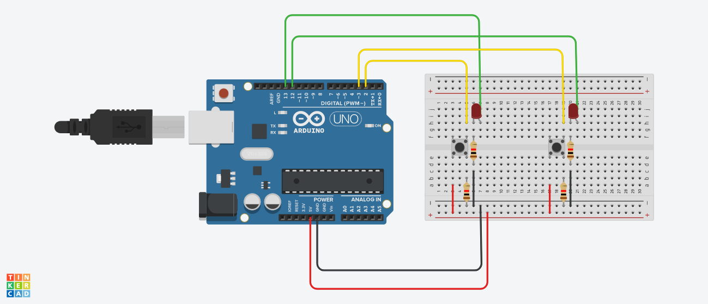
CODE:

// C++ code
//
int buttonState = 0;

int unnamed = 0;

int i = 0;

void setup()
{
pinMode(2, INPUT);
pinMode(13, OUTPUT);
pinMode(3, INPUT);
pinMode(12, OUTPUT);
}

void loop()
{
buttonState = digitalRead(2);
if (buttonState == HIGH) {
digitalWrite(13, LOW);
} else {
digitalWrite(13, HIGH);
}
buttonState = digitalRead(3);
if (buttonState == HIGH) {
digitalWrite(12, LOW);
} else {
digitalWrite(12, HIGH);
}

buttonState == HIGH;
delay(10); // Delay a little bit to improve simulation performance
}

RESULT:

Interface two switches and LEDs to Arduino UNO using C++ is done.

